Week 6: Database Integration and CRUD Operations

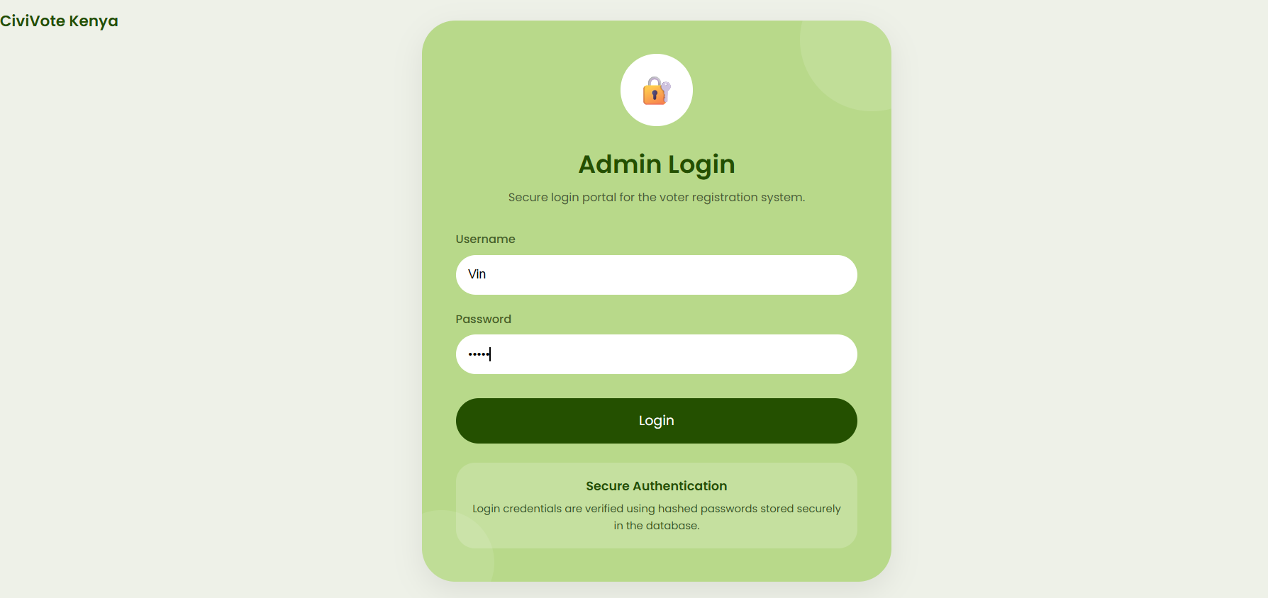
Figure 26: Administrator login page used to authenticate authorized users.


Figure 27: Administrator dashboard displayed after successful login.

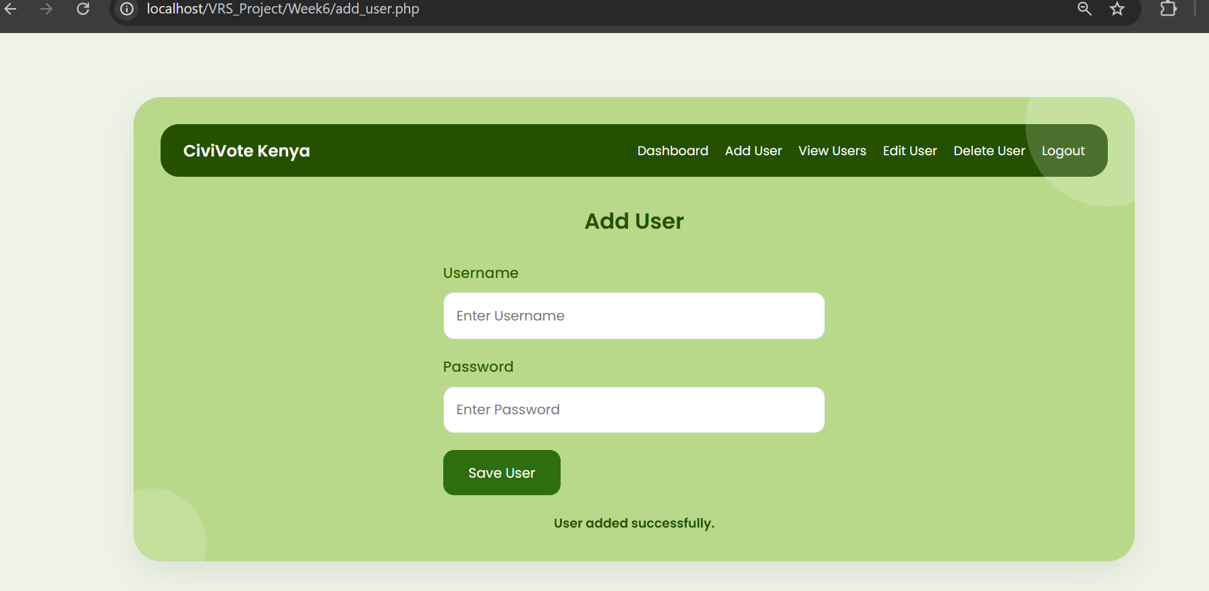
Figure 28: User registration form used to add new system users to the database.

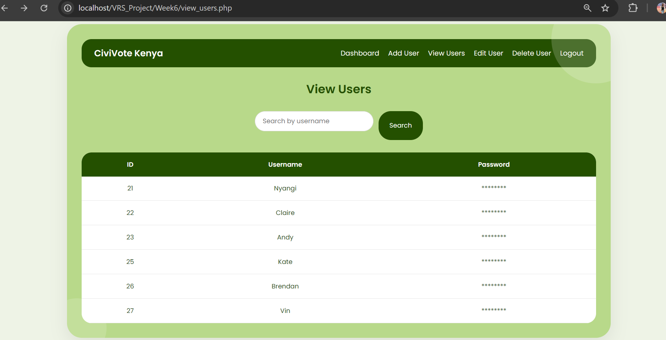
Figure 29: Display of user records retrieved dynamically from the MySQL database.
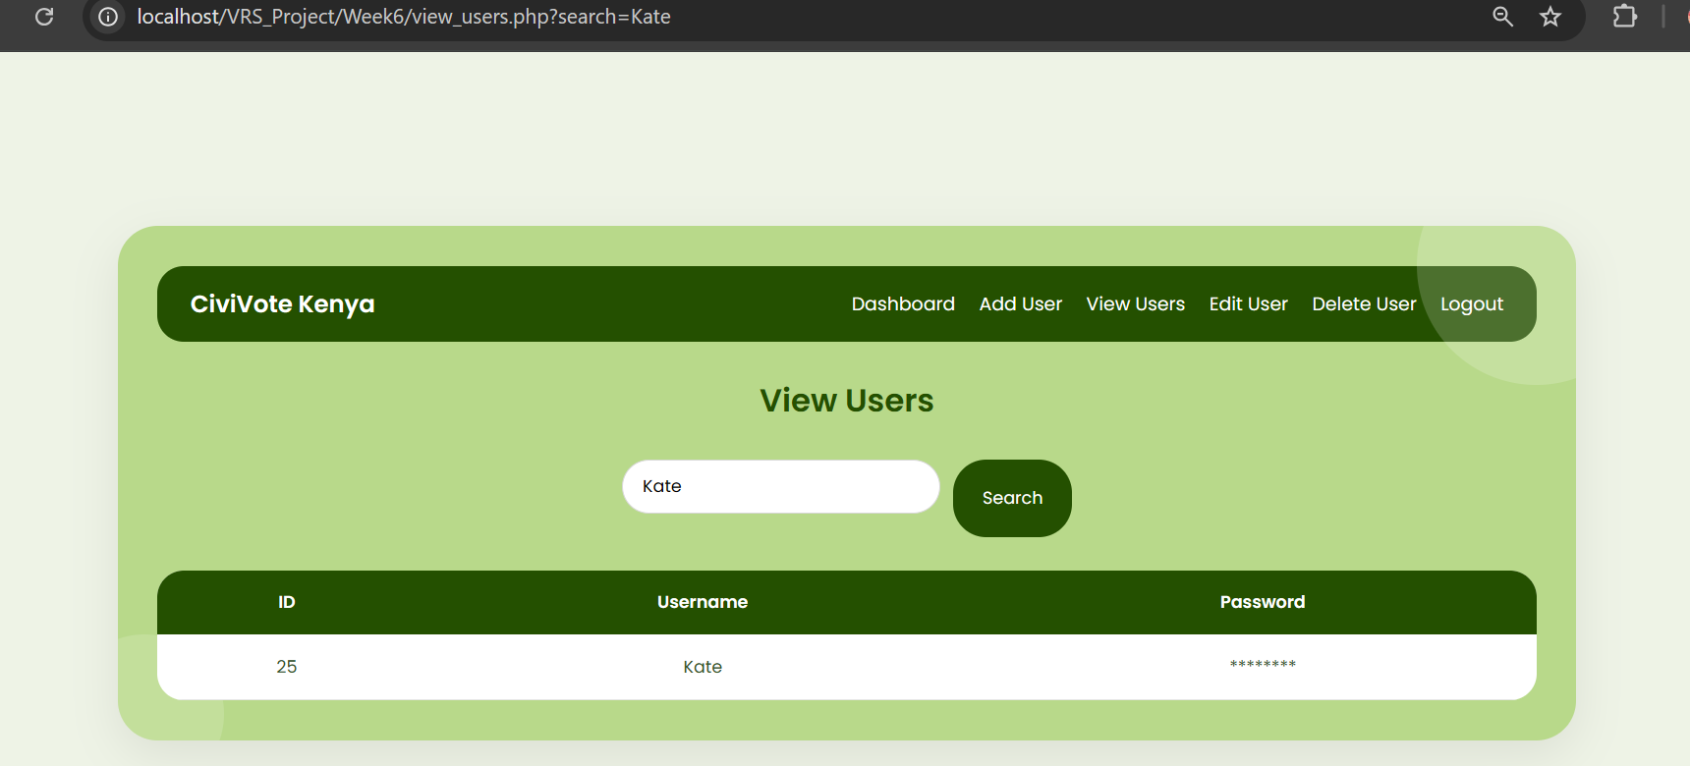
Figure 30: Search functionality used to retrieve a specific user record.

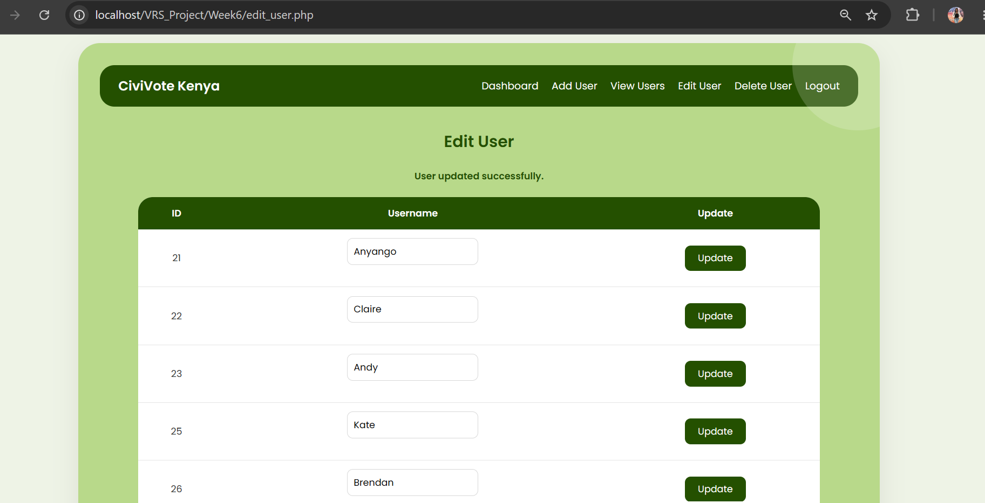
Figure 31: Interface used to modify existing user information.

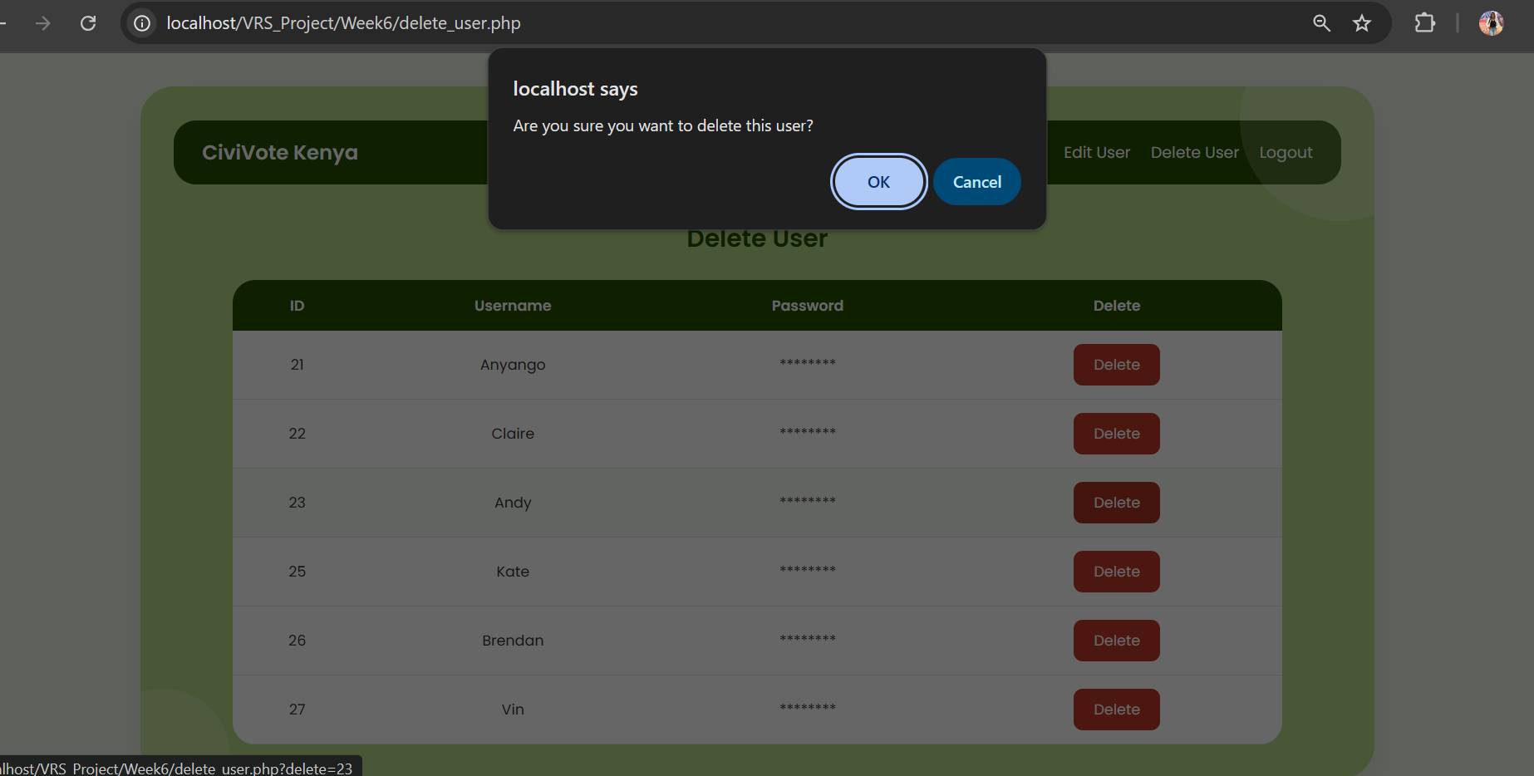
Figure 32: Confirmation dialog displayed before deleting a user record.
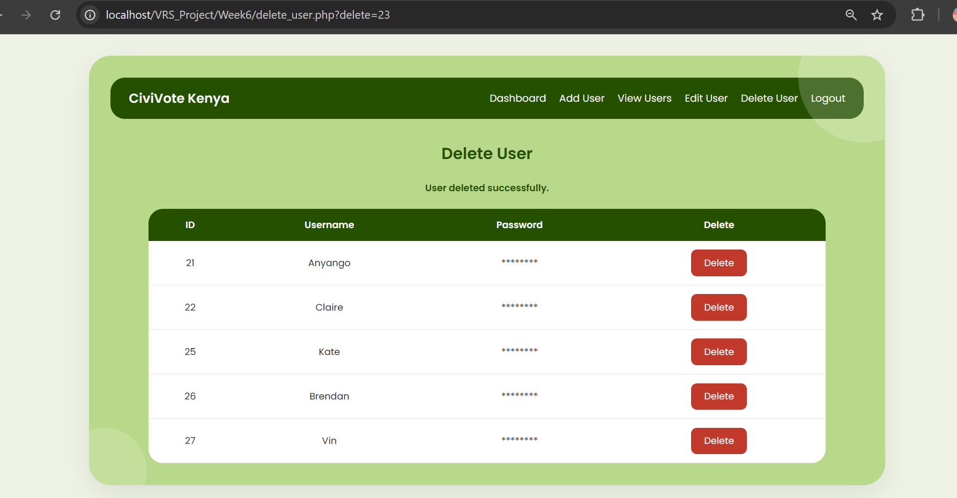
Figure 33: Successful deletion of a user record from the database.

